FIDGET PUCK | FPUCK
Customer Marketing Resource

The fidget, reinvented. Made for brands.

Product Overview
The Fidget Puck is a premium tactile fidget and focus tool, designed and manufactured in the UK from 100% recycled plastic. It features four distinct sensory elements built into a compact, circular, palm-sized body - and two large, flat, print-ready branding faces that no cube, spinner or stress ball can match.
It is a product with genuine purpose. Branded Fidget Pucks work as corporate gifts, focus aids, and a visible statement of inclusive values. Schools, colleges, universities and employers are all strong markets.
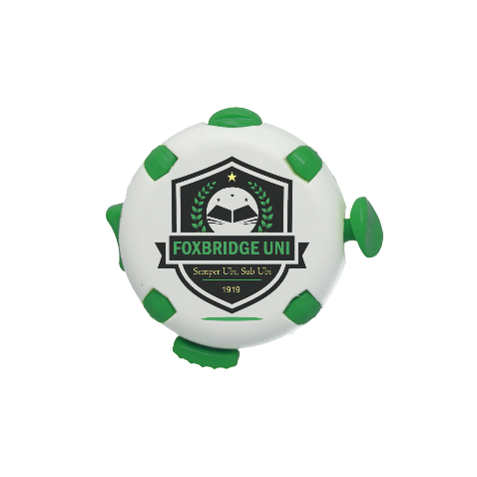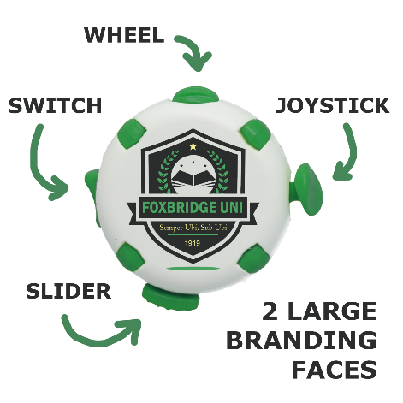

Key Features
- Four fidget elements: toggle switch, clicking slider, joystick and spinning wheel
- Circular, palm-sized form - comfortable in one hand, pocket-sized
- Two large, flat branding faces - identical in specification, both print-ready
- Print one face or both for maximum brand coverage
- Full-colour CMYK digital print as standard
- UK-designed and manufactured - Cornwall facility
- 100% recycled plastic as standard. R+ recycled biodegradable option available
- Fast dispatch. Next day dispatch also available - ask a member of our sales team

Product Specifications
Product Code | FPUCK
Form | Circular, palm-sized
Fidget Elements | 4 - toggle switch, clicking slider, joystick, spinning wheel
Branding Areas | Two large flat faces, identical specification both sides
Sides Printed | One or both
Print Method | Full-colour digital CMYK
Material | 100% recycled plastic (standard)
R+ Available | Yes - recycled biodegradable option available
Body Colour | White as standard. Coloured body available at coloured price.
Element Colours | Choice of 8 element colours including white at standard white price
Made | UK - Cornwall
Dispatch | Fast dispatch. Next day dispatch available.

Colour Options

Standard Recycled Plastic
White body as standard. Coloured body available at coloured price. Element colour choice from 6 options (including white) at standard white price.
Element colour options: White, Black, Red, Orange, Yellow, Green, Blue, Purple

R+ Recycled Biodegradable
R+ Tor (off-white speckled) is available at standard white price. R+ Sky, Buoy, Seaweed and Sand available at coloured price.
R+ features a distinctive natural speckled finish and includes a biodegradable additive that accelerates end-of-life breakdown, whilst remaining fully recyclable during use.

The Branding Advantage
Where most competitor fidget products offer a small, limited, curved, or fragmented print area, the Fidget Puck offers two large, flat faces that carry full-colour artwork with genuine impact.
Print one side for a bold single-brand statement, or use both faces to carry additional messaging, a QR code, or campaign copy on the reverse.

Why Your Customers Will Love It
The Fidget Puck works across a wide range of end-user contexts:
- HR and people teams: new starter packs, staff wellbeing initiatives, neurodiversity awareness campaigns
- Schools and colleges: classroom resource kits, SEN departments, end-of-year gifts
- Universities: freshers packs, student union merchandise, mental health campaigns
- Healthcare and therapy: OT practices, mental health charities, branded sensory kits
- Events and corporate gifting: a product recipients genuinely keep and use

Suggested Copy
Use or adapt the following copy for your product listings, emails or social posts.

Short product description (for listings)
The Fidget Puck is a UK-made, recycled plastic focus tool with four built-in fidget elements and two large, flat, full-colour branded faces. Toggle switch, clicking slider, joystick and spinning wheel - more sensory variety than any comparable product. Print one side or both. A practical, purposeful gift for wellbeing, inclusivity and brand awareness.

Short product description (alt - event / gifting angle)
A premium branded fidget tool that people actually keep. The Fidget Puck features four tactile sensory elements and carries your logo across two generous, print-ready faces. UK-made from 100% recycled plastic. The ideal addition to a welcome pack, wellbeing kit, or event gift bag.

Social post copy
Branded merchandise that means something. The Fidget Puck is UK-made, fully recycled, and packed with four tactile fidget elements - plus two large print faces that carry your brand with real impact. Perfect for wellbeing packs, education and corporate gifting. Get in touch to see samples or discuss a quote.

Sustainability Credentials
- Made from 100% post-consumer recycled plastic - no virgin plastic
- R+ biodegradable option available at no extra cost in Tor (off white)
- Manufactured at solar-powered, zero-waste Cornwall facility
- All plastic offcuts recrushed and reused in production
- Made in the UK - short supply chain, reduced transport emissions

